Allgemeiner Deutscher Rottweiler-Klub (ADRK) e. V.  Südring 18  32429 Minden | 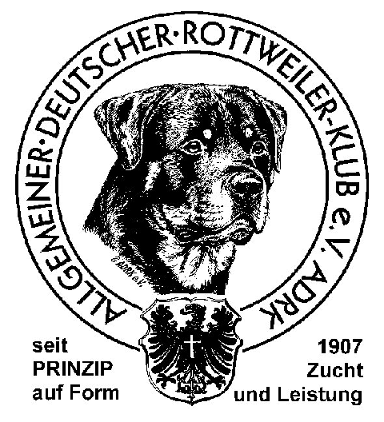

Contract to use DOGBASE with data of the
Allgemeiner Deutscher Rottweiler-Klub e. V.

Name
Street
ZIP Code, Town |  | Phone
E-Mail |  | ADRK-Membership No.
I would like to access the breeding data of the Allgemeiner Deutscher Rottweiler-Klub e. V. and confirm with my signature the following agreements:
Dogbase-Online is copyrighted with its data. Any use is only allowed for private purposes. The transfer of the data to third parties, the transfer of the data to other media, as well as the copying of the data is prohibited and will be prosecuted.
The license agreement is valid for one calendar year and is tacitly renewed for another year if not cancelled in writing 4 weeks before the beginning of a new calendar year.
With the termination of membership in the ADRK, this agreement also expires without the need for a separate notice of termination.
The user fee per year is 65 €. Price increases on the part of the TG-Verlag or the ADRK are reserved. The user fee is due for the entire year in advance by credit card, PayPal, bank transfer, etc.
The user receives a password for the use of Dogbase-Online via the TG-Verlag. This password is only valid for the person who signed the license agreement. Passing it on to third parties is punishable by law and will be punished accordingly.
In case of non-payment of the user fee, the ADRK reserves the right to block the user's access. After leaving the club, the access is no longer valid.
I agree that my data will be stored electronically within the framework of the Federal Data Protection Act (BDSG).

Place, date Signature of user
Please see following page!

DOGBASE fees may be charged from my credit card

Card/Account No. (all digits): - - -

Expiration date: / Card Control No.: (last 3 digits in signature field)

VISA EUROCARD / MASTERCARD

Name, First Name:

Street / No.:
Zip Code / Town: |  |  |  |  |  |  |  | Country:
Date / Place: |  |  |  | Signature

Bank Account:
Volksbank Minden, IBAN: DE31 490 603 920 632 111 200,
BIC (SWIFT-Code): GENO DE M1 MND

PayPal: shop@adrk.de

